**Year 8 – Gradient**

1. The following lines are drawn on a unit grid (i.e. each square is 1 unit). Determine the gradient of each line.  
   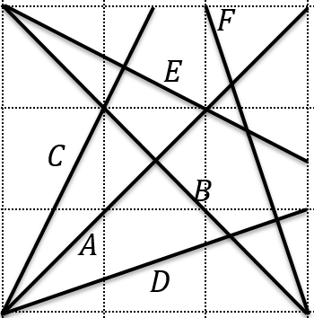
2. Determine the gradient of the line which goes through the following pairs of points:
   1. $(0,0)$ and $\left(4,8\right)$
   2. $(2,3)$ and $\left(4,15\right)$
   3. $(5,2)$ and $\left(7,5\right)$
   4. $(5,6)$ and $\left(7,-2\right)$
   5. $(-3,2)$ and $\left(5,-6\right)$
   6. $(7,8)$ and $\left(10,0\right)$
3. Find the gradient of the lines with the following equations:

$y=5x+2$

$y=2-5x$

$2y=5x+2$

$x+y=3$

$2x+y=3$

$x+2y=3$

$x-2y=3$

**Answers:**

1. (A) 1 (B) -1 (C) 2 (D) $\frac{1}{3}$ (E) $-\frac{1}{2}$ (F) -3
2. –
   1. 2
   2. 6
 $\frac{3}{2}$

  3. -4
   4. -1
 $-\frac{8}{3}$

 $-$

 5. 5
   6. -5

$\frac{5}{2}$

$-1$

$-2$

$-\frac{1}{2}$

$\frac{1}{2}$